Day 3 Task: Basic Linux Commands

Task: What is the linux command to

1. To view what's written in a file.

cat command is used to read or view content of the file.

1. To check the access permissions of files.

ls command with –l parameter is used to view the access permissions of the files.

1. To check which commands you have run till now.

history command is used to check the previous commands run.

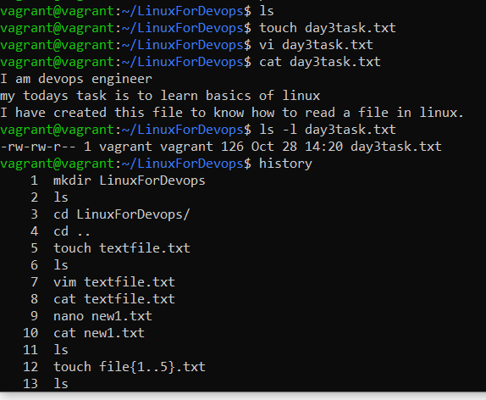

1. To remove a directory/ Folder.

rmdir command is used to remove directory or folder

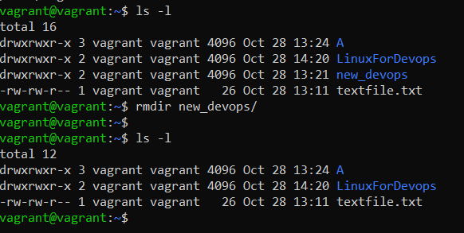

1. To create a fruits.txt file and to view the content.

vi or touch command is used to create a new file and cat command to view the contents of the file.

1. Add content in devops.txt (One in each line) - Apple, Mango, Banana, Cherry, Kiwi, Orange, Guava.

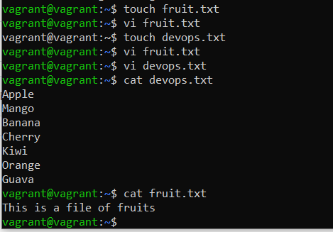

1. To Show only top three fruits from the file.

**head -3 fruit.txt**

1. To Show only bottom three fruits from the file.

**tail -3 fruit.txt**

1. To create another file Colors.txt and to view the content.

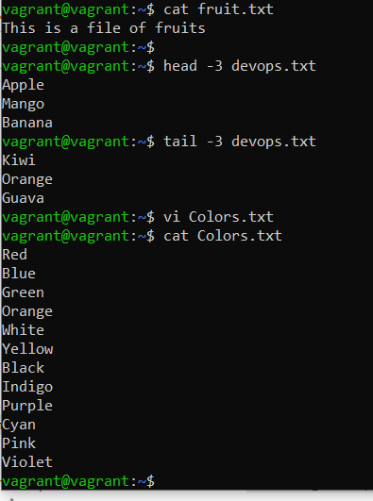

1. Add content in Colors.txt (One in each line) - Red, Pink, White, Black, Blue, Orange, Purple, Grey.
2. To find the difference between fruits.txt and Colors.txt file.

**#diff fruits.txt colors.txt**is used to find the difference between fruits.txt and Colors.txt file.